Product Requirements Document (PRD): N8N Sales AI Agent

1. Executive Summary & Objective
The core objective of this project is to develop a fully automated, intelligent Sales AI Agent utilizing N8N as the central orchestration engine. This agent will integrate seamlessly with the WhatsApp Business API to interact with prospects and customers. Its primary function is to ingest predefined OKRs (Objectives and Key Results) and KPIs from the management team, intelligently steer the conversation to meet these strategic targets, persuasively negotiate with the customer, perform automated follow-ups, and notify the human sales team immediately once the customer is convinced and ready to sign the contract.

2. Target Audience & User Personas
- The Customer (End-User): Seeking services or products, prefers quick, asynchronous, and natural communication via WhatsApp. Expects personalized and immediate responses.
- The Sales Manager (Admin/Stakeholder): Sets the strategic OKRs and KPIs (e.g., minimum margin, focus products) that dictate the AI Agent's negotiation boundaries and overarching goals.
- The Human Sales Representative: Steps in exclusively at the final stage to close the deal, prepare the paperwork, and sign the contract after the AI has successfully completed the lead nurturing and negotiation phases.

3. Product Features & Requirements

3.1 WhatsApp Business API Integration via N8N
- Requirement: Establish a robust, bi-directional communication channel between the N8N workflow and the WhatsApp Business API.
- Details: Utilize N8N Webhook nodes to receive incoming user messages, status updates, and read receipts in real-time. Use HTTP Request nodes to send text, documents, and interactive message templates back to the customer.

3.2 OKRs & KPIs Ingestion & Routing System
- Requirement: A dynamic mechanism to feed business objectives into the AI's core negotiation logic.
- Details: Managers can input specific targets (e.g., "Push for an annual subscription over monthly", "Do not offer more than a 10% discount"). N8N will fetch these variables from a database or spreadsheet and dynamically inject them into the LLM's system prompt to constrain and guide the AI's responses.

3.3 AI Persuasion & Negotiation Engine
- Requirement: An LLM-powered cognitive engine capable of natural conversation, complex objection handling, and persuasive negotiation based on the ingested OKRs.
- Details:
  - Integration with LLMs (e.g., Gemma 4, Qwen 2.7, or Gemini 1.5 Pro) via N8N specialized nodes.
  - Maintain a continuous conversation history (Memory Component) per user phone number to ensure context continuity across multiple days.
  - Implement semantic routing to identify customer intent (e.g., asking a question, raising an objection regarding price, or agreeing to terms).

3.4 Automated Follow-Up System
- Requirement: Prevent lead drop-off by automatically reaching out to unresponsive leads at strategic intervals.
- Details: Utilize N8N 'Wait' nodes or scheduled Cron triggers. If a user does not reply within a specified timeframe (e.g., 24 hours), the system will trigger the LLM to generate a context-aware, polite follow-up message designed to re-engage the prospect without being overly aggressive.

3.5 Deal Closure & Hand-off Notification System
- Requirement: Alert the human team exactly when the AI successfully secures a verbal or textual agreement from the customer.
- Details: Once the intent classifier detects "Ready to Sign", "Agreed", or "Send the contract", N8N will immediately pause the AI's direct responses and trigger a critical alert (via Whatsapp, Email, and internal CRM/Dashboards). This alert will contain a concise summary of the negotiation, the agreed-upon terms, and a direct link to the customer's contact details.

4. System Architecture & Data Flow
The standard operational workflow in N8N will follow this sequence:
- Trigger: Customer sends a WhatsApp message. N8N Webhook captures the JSON payload.
- Pre-processing: Retrieve the user's profile and historical chat logs from the operational database (e.g., PostgreSQL).
- Context Injection: Fetch the current organizational OKRs & KPIs and append them to the LLM System Prompt.
- AI Processing: Transmit the aggregated payload to the LLM API to generate a persuasive, goal-oriented response.
- Intent Action: Evaluate the LLM's output intent. If "Deal Closed", trigger notification to the Sales Team. If "Normal Chat", send the generated response via the WhatsApp API.
- Wait State: Initiate a wait timer for potential automated follow-up if no subsequent reply is received.

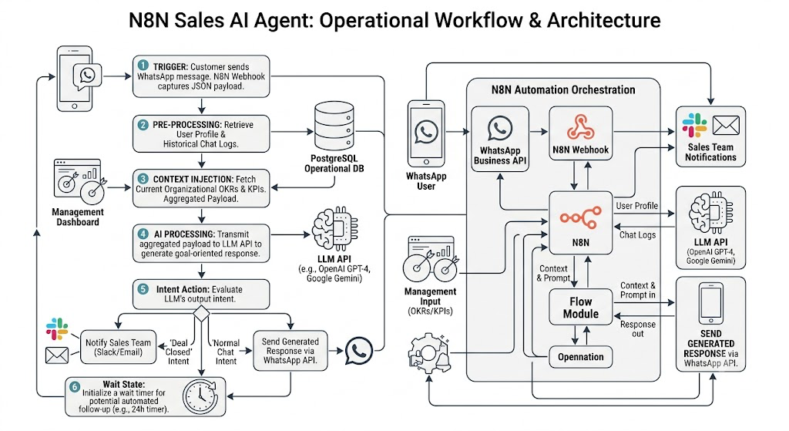

5. Non-Functional Requirements
Requirement | Description
Latency & Performance | The system must process the incoming webhook, query the LLM, and dispatch the WhatsApp response within 3-5 seconds to maintain a natural conversational flow.
Availability & Scalability | The N8N instance must maintain 99.9% uptime. It must be configured to handle concurrent webhook executions during high-volume marketing campaigns.
Security & Privacy | Sensitive Personally Identifiable Information (PII) must be handled securely and, where possible, masked before being sent to external LLM providers.

6. Success Metrics (KPIs for the AI Agent)
- Lead Conversion Rate: The percentage of total AI-managed conversations that result in a "Ready to Sign" handover.
- Average Handling Time: The duration from the initial lead interaction to successful deal closure.
- Follow-up Revival Rate: The percentage of previously unresponsive conversations successfully re-engaged by the automated follow-up system.
- Human Intervention Rate: The frequency at which human agents need to manually interrupt the AI due to errors or complex unhandled queries (Target: minimize).

